**25)**

**Aim:** To Draw a Deterministic Finite Automata for the language accepting strings ending with ‘abba’ over input alphabets ∑ = {a, b}.

**Diagram:**

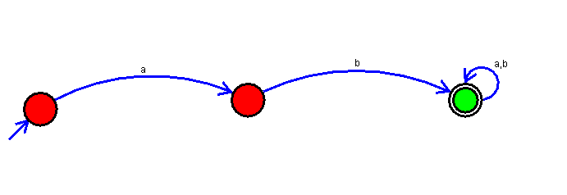

**Result:**

Thus, successfully executed Deterministic Finite Automata for the language accepting strings ending with ‘abba’ over input alphabets ∑ = {a, b}.